BASAVESHWAR ENGINEERING COLLEGE (AUTONOMOUS). BAGALKOT

 Department of Electronics and Communication

CERTIFICATE

This used to certify that project entitled “contact book” is a work of Miss. Swati Bangari [USN-2BA21EC115] and Miss. Aishwarya Hiremath [USN-2BA21EC007]. The report satisfice the academic requirements with respect to project work describe for 3rd semester during the academic year 2022-23.It is satisfied that all suggestions/corrections indicated assessment of the project have been satisfied.

Project Guide:. Head of department

Prof.M.C.Aralimarad. Dr. Shridhar Kuntoji

Signature with date

Introduction:

Creating a contact book is an excellent project for someone with moderate Python skills. We'll add contacts to the book and search them using the person's name, thus this somehow ties up with the usage of data structures and methods. Contact book… that contains the person's names and their respective mobile numbers. In this program we can add, edit ,search and delete the contact numbers and display it. using python language we created this contact book. Contact books are a useful and widely used kind of application. They're everywhere. You probably have a contact book on your phone and on your computer. With a contact book, you can store and manage contact information for your family members, friends, coworkers, and so on. It is a try to understand the different Syntaxes in python through this contact book program. In this program we used different syntaxes of python such as dictionary, loops like while loop, if elif else statements, functions, in statement etc .

Explanation of project code :

Dictionary:

Python dictionaries allow us to associate a value to a unique key, and then to quickly access this value. It’s a good idea to use them whenever we want to find (lookup for) a certain Python object. Dictionaries are used to store data values in key :value pairs. Here we used a dictionary named contact we stores the persons names and their contact numbers.

**Functions:**

A function is a block of code which only runs when it is called. You can pass data, known as parameters, into a function. A function can return data as a result. In this we used a function named display_ contact() to display the contents of the dictionary .

**While true:**

While loop is used to execute a block of code repeatedly until given Boolean condition evaluated to False. If we write while True then the loop will run forever. In this program we used this syntax before we choose the choices. Using this while true we can enter our choice as many times as we want and exit from the program when we want.

**If and elif statement:**

If ..allows for conditional execution of a statement or group of statements based on the value of an expression. Elif means that when the if statement is false, the next elif expression is checked. In this program we used these syntaxes to switch the choices entered.

**Else statement:**

The if-else statement is used to execute both the true part and the false part of a given condition. If the condition is true, the if block code is executed and if the condition is false, the else block code is executed. In this program we used this else part within the elif and also at last of the program code . because if the choice entered by the user is not valid the it directly goes to the else part and come out from the program. And also we used input statement to access the information from the user from keyboard. And also we used ‘in’ statement is used to search or delete the desired person name in the dictionary named contact.

PROGRAM FOR CONTACT BOOK :

contact = {}

def display_contact():

print("Name\t\t contact number")

for key in contact:

print("{}\t\t{}".format(key,contact.get(key)))

while True:

choice=int(input("1.add contact\n 2.search contact\n 3.display contact\n 4.edit contact\n 5.delete contact\n 6.exit\n"))

if choice==1:

name=input("enter the contact name\n")

phone_number=input("enter the contact number\n")

contact[name]=phone_number

elif choice==2:

search_name= input("enter the contact name\n")

if search_name in contact:

print(search_name,"'s contact number is",contact[search_name])

else:

print("name is not present in contact book\n")

elif choice==3:

if not contact:

print("empty contact\n")

else:

display_contact()

elif choice==4:

edit_contact=input("enter the contact name to be edited\n")

if edit_contact in contact:

phone_number=input("enter the contact number\n")

contact[edit_contact]= phone_number

print("contact updated\n")

display_contact()

else :

print("name is not present in contact book\n")

elif choice==5:

delete_contact=input("enter the contact name to be deleted\n")

if delete_contact in contact:

confirm=input("Do you want to delete this contact?y/n")

if confirm=='y'or confirm=='Y':

contact.pop(delete_contact)

display_contact()

else :

print("name is not present in contact book\n")

else:

break

OUTPUT : 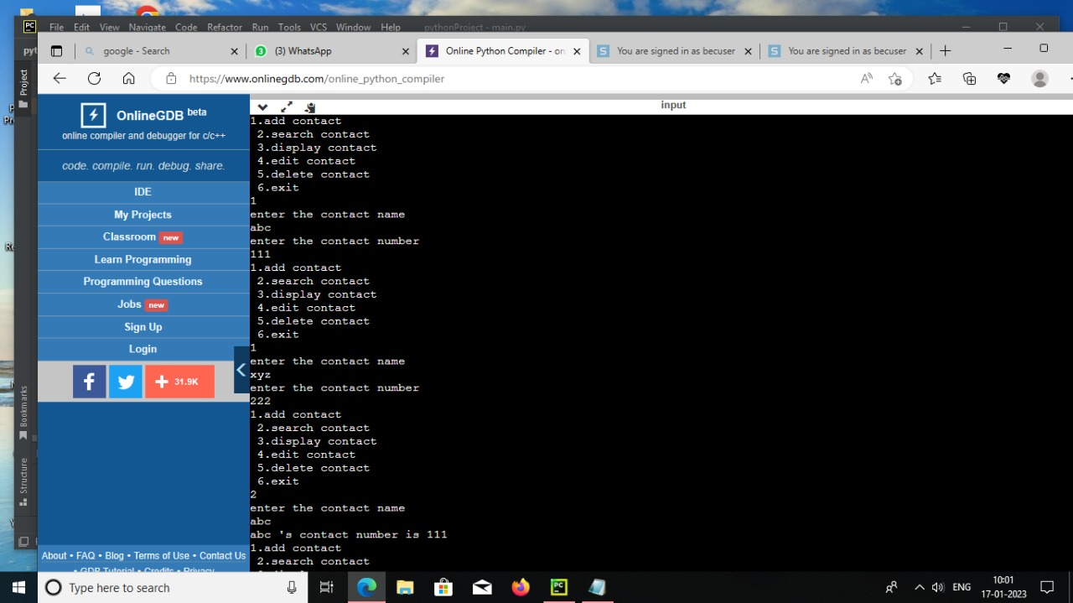

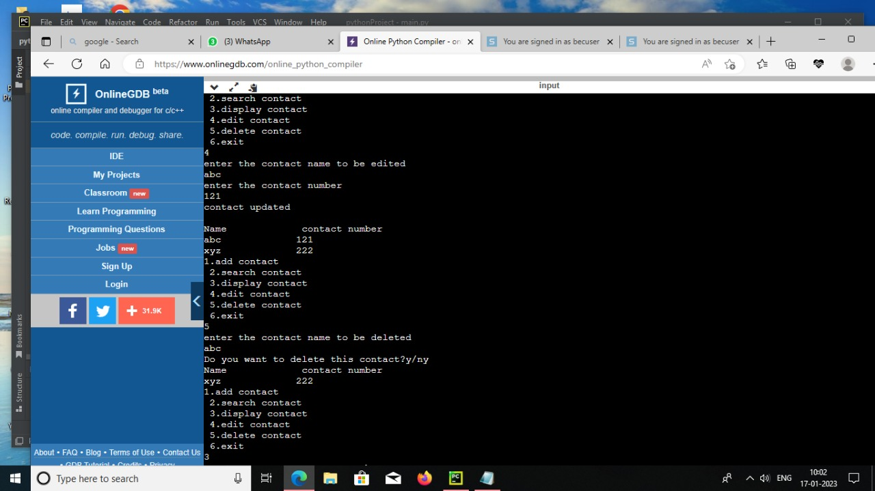

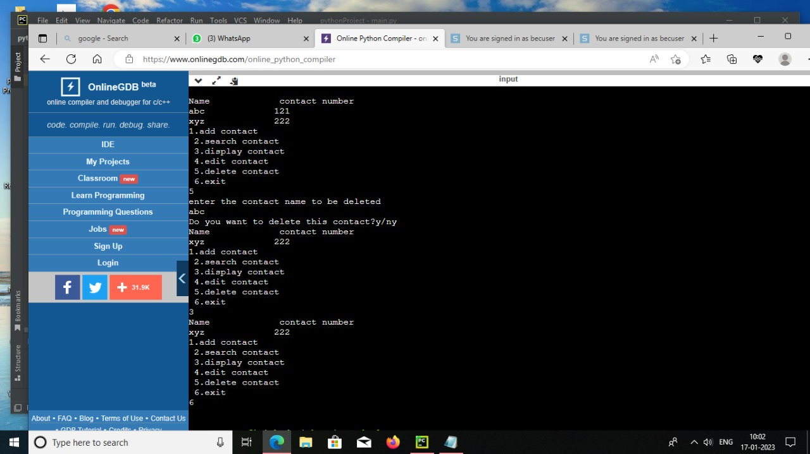

CONCLUSION :

From this project we can understand the concept to use the python programming language to develop a simple contact book, using different syntax of python. From this we can add ,search, delete , edit and display person's contact number.